Death Investigation

Update 2/16/24: The deceased male in this investigation has been identified as Richard E. Crowder, 74-years-old, of Mink Shoals. This is still an active death investigation, and no further information will be released at this time. See Attached Photograph.

IMMEDIATE RELEASE
Lieutenant A.C. Pile
anapile@kcso.us

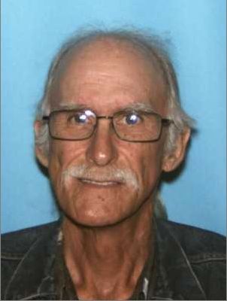 Photo courtesy of WV DMV (Richard Crowder)
______________________________________________________

Update 2/13/24, 7:30 p.m. – The suspicious death investigation on Otter Lane in Mink Shoals remains under investigation as detectives continue to process evidence at the scene.
Crime Scene Investigators have identified the male as a Mink Shoals resident in his 70s; however, specific details regarding his identity are currently being withheld until notification has been made to his family. We hope to release more details about the victim in the coming days.
We can confirm the victim suffered from a single gunshot wound and was found lying on the floor in his home. Detectives are working to put a timeline together and it is believed the incident may have occurred between Sunday and today.
Detectives have been canvassing the area all afternoon, collecting evidence, and interviewing potential witnesses; however, no suspects have been identified or charged at this time. We encourage anyone with any information to please reach out to Lieutenant S.D. Snuffer at 304-357-0556.
____________________________________________________

Mink Shoals, WV- Kanawha County Sheriff’s Office Detectives are currently on scene and investigating a suspicious death at 6 Otter Lane in Mink Shoals.
Deputies responded to this residence after a healthcare worker for seniors requested a well-being check on a resident of the home. The worker was here to check on a patient with known medical issues but received no answer at the door or by telephone.
Deputies and medics arrived at the scene and made entry into the residence where they located a deceased male. The male has not been identified at this time.

FOR IMMEDIATE RELEASE: Contact: Lieutenant A.C. Pile
anapile@kcso.us

